**MESD Documentation LMS-63-Evaluations**

**Purpose**

To allow for the detailed and robust evaluation of performance for a learner.

**Background**

In the LMS we have access to a range of powerful evaluation tools we detail them and how to use them below.

**Scales**

Scales are a way of evaluating or rating a students' performance. Administrators can create standard scales which are available across the site, and teachers can create custom scales just for their own course. (If you prefer, you can use [grade points](https://docs.moodle.org/403/en/Grade_points) or no grade at all.)

Scales may be used in [Forums](https://docs.moodle.org/403/en/Forums), [Glossaries](https://docs.moodle.org/403/en/Glossaries) and [Assignments](https://docs.moodle.org/403/en/Assignments) for rating and/or [grading](https://docs.moodle.org/403/en/Grades) a student's activity.

**Creating a new scale**

New scales can be created by teachers with editing rights or by administrators or by any user with the [manage scales role capability](https://docs.moodle.org/403/en/Capabilities/moodle/course:managescales).

**Creating course scales**

* Click the "Add a new scale" button in *Course administration > Grades > Scales*.
* On the next page give your scale a name in the Name box that will identify it among other scales.
* 'Standard' scale is a scale which can be applied to every course in Moodle. Only those with site permissions such as administrators can make a new scale 'standard'. A regular teacher can only create a scale for their own course.

[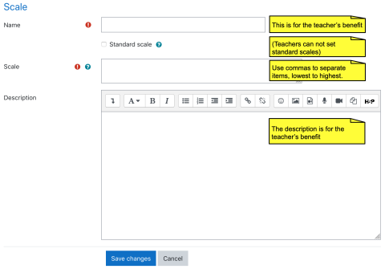](https://docs.moodle.org/403/en/File:newscale.png)

Creating a new scale screen: Name, Scale, Description areas

* In the Scale box, create your scale. Each item in the scale should be separated by a comma. You can use as many options here as you require. You must order the comma separated elements in increasing order of value. **For example, an A,B,C,D scale must be entered as D,C,B,A**.
* Write a detailed description in the Description box to remind you (or other teachers) of how the scale is to be used.
* Save the changes.

**Single rating scale**

Only selecting one option allows you to create a "Like" scale similar to Facebook or a "Useful" scale similar to that on Moodle.org.

[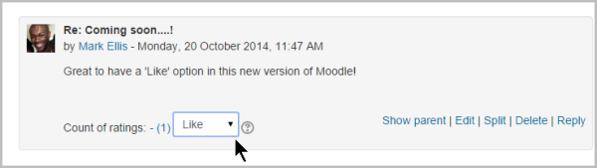](https://docs.moodle.org/403/en/File:Like28.png)

Creating a standard scale

An administrator can create a standard scale which can be used in any course in *Administration > Site administration > Grades > Scales*

**Using scales**

A teacher may select a scale by going to the *Edit settings* screen of an activity, for example an [assignment](https://docs.moodle.org/403/en/Assignment), scrolling to 'Grade' and then selecting 'Scale' from the *Type* dropdown:

[](https://docs.moodle.org/403/en/File:scale1.png)

This will then open up the 'Scale' dropdown, allowing them to choose the scale they wish to use.

Editing a scale

If a scale has not yet been used, you will see an edit and delete icon in the edit column.[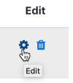](https://docs.moodle.org/403/en/File:scalesedit.png)

Once a scale is used for an activity, it is no longer possible to delete it, and you can only edit the scale name and description.

**Example scales**

* *The Cool Scale* - Not cool, Not very cool, Fairly cool, Cool, Very cool, The coolest thing ever!
  + (Valued as 0/5pts, 1/5pt, 2/5pts, 3/5pts, 4/5pts, and 5/5pts respectively in **any normalized aggregation method**)
  + (Valued as 1, 2, 3, 4, 5, and 6 respectively in the **sum aggregation method**)
* *General Introductions (The Affirmative Scale)* - Welcome!, Glad to have you here!, Great post!
  + (Valued as 0/2pts, 1/2pt, and 2/2pts respectively in any **normalized** aggregation method)
  + (Valued as 1, 2, and 3 respectively in the **sum** aggregation method)
* If you would like two options in your scale (incomplete and complete) type "incomplete, complete" in the scale box.
  + (Valued as 0/1pts and 1/1pt respectively in any **normalized** aggregation method like weighted mean, mean, simple weighted mean, etc.)
  + (Valued as 1 and 2 respectively in the **sum** aggregation method)
* *Generic Social Forum* (This scale only worked prior to the averaging function) - Please clarify., I don’t understand., Hmmm. Tell me more., Interesting, Very cool., Awesome!
  + (Valued as 0/6pts, 1/6pt, 2/6pts, 3/6pts, 4/6pts, 5/6pts, and 6/6pts respectively in any **normalized** aggregation method)
  + (Valued as 1, 2, 3, 4, 5, 6, and 7 respectively in the **sum** aggregation method)
* "Refer", pass, merit, distinction
  + (Valued as 0/2pts, 1/2pt, and 2/2pts respectively in any **normalized** aggregation method)
  + (Valued as 1, 2, and 3 respectively in the **sum** aggregation method)
* "Hesitant" Fail, Acceptable, Average, Excellent
  + (Valued as 0/3pts, 1/3pt, 2/3pts, and 3/3pts respectively in any **normalized** aggregation method)
  + (Valued as 1, 2, 3, and 4 respectively in the **sum** aggregation method)
* "Stars" ☆----, ☆☆---, ☆☆☆--, ☆☆☆☆-, ☆☆☆☆☆
  + (Valued as 0/4pts, 1/4pt, 2/4pts, 3/4pts, and 4/4pts respectively in any **normalized** aggregation method)
  + (Valued as 1, 2, 3, 4, and 5 respectively in the **sum** aggregation method)

**Values calculated as percentage scores**

Moodle uses the last entry to determine the number of points in the scale for computing percentages. For example, if your scale is 0,5,6,7,8,9,10 then Moodle will use a 0-6 or 1-7 point scale depending on your chosen aggregation method.

* When using a **normalized** aggregation method, 0 will become 0/6, 5 will become 1/6, 6 will become 2/6, 7 will become 3/6, 8 will become 4/6, 9 will become 5/6, and 10 will become 6/6 for grade computation, respectively.
* When using the **sum** aggregation method, 0 will become 1, 5 will become 2, 6 will become 3, 7 will become 4, 8 will become 5, 9 will become 6, and 10 will become 7.

Either way, the numbers you enter for your scale are **NOT** calculated as entered, the system calculates the number of non-zero entries and then creates a scale from 0 to the total number of entries (n) with their values calculates as 0/n, 1/n, 2/n, 3/n....

*TIP:* If your scale is a custom non-value (not a number), Moodle's behavior in combining or averaging the scores into a percentage value is unpredictable. When an average or aggregate is important, then it is a good idea to stick with the standard 100% scale to compute an overall grade.

*TIP:* Some sites do not like the "0" (zero) in any normalized aggregation method.

**Outcomes**

**What are outcomes?**

Outcomes are specific descriptions of what a student has demonstrated and understood at the completion of an activity or course. Each outcome is rated by some sort of [scale](https://docs.moodle.org/403/en/Scales). Other terms for outcomes are 'Competencies' and 'Goals'.

In simple terms outcomes are similar to sub components of a grade. A grade is an assessment of overall performance that may include tests, participation, attendance and projects. Outcomes assess specific levels of knowledge through a series of statements, that maybe coded with numbers or letters. Thus an overall grade can be given for a course, along with statements about specific competencies in the form of outcomes.

**Enabling outcomes**

To enable outcomes to be used in any course on the site

1. Go to *Site administration > Advanced features*
2. Tick the *Enable outcomes* checkbox
3. Save changes

**Adding course-level outcomes**

[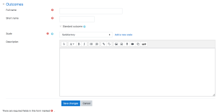](https://docs.moodle.org/403/en/File:addnewoutcome.png)

**Adding an outcome**

To add a course-level outcome:

1. Click the 'Edit outcomes' link in *Course administration > Outcomes*
2. Click the 'Add a new outcome' button
3. Complete the form then click the 'Save changes' button.

**Adding standard outcomes**

An administrator can add standard outcomes, which are available site-wide, in *Site administration > Grades > Outcomes*. Multiple standard outcomes can be added using the import outcomes functionality (see below).

**Using outcomes**

1. Choose or define some outcomes for your course (as described above).
2. For each activity, choose which of these outcomes apply using the checkbox in the activity's settings page.
3. When grading that activity, grade each student using the Outcome scales. Note: You can also edit the grades in the [Grader report](https://docs.moodle.org/403/en/Grader_report) (useful for modules that don't feature inbuilt grading).
4. Use the outcomes as part of the assessment for students, or look at the Outcomes report for some useful feedback on how students in the class in general are performing.

**How do I remove a selected outcome from an activity?**

Previously selected outcomes are greyed out on the update activity page. To remove an outcome

1. Go to *Course administration > Gradebook setup*
2. Locate the outcome (below or above the activity they have been enabled in) then in the actions column click edit and then delete.

Deleting the outcome will result in the outcome being deselected on the update activity page.

**How do I change the scale associated with an outcome?**

The scale associated with an outcome can only be changed if the outcome is not selected for use with an activity.

1. Go to *Course administration > Outcomes*
2. Check that the outcome has zero in the items column i.e. it is not used in any activity. If not, go to *Course administration > Gradebook setup* and delete all instances of the outcome.
3. Return to *Course administration > Outcomes* and click the edit icon opposite the outcome
4. Change the scale
5. Click the 'Save changes' button.

**Outcomes report**

The outcomes report in *Course administration > Grades > Outcomes report* helps teachers monitor their students' progress using outcomes. It lists site-wide outcomes and custom outcomes used in the current course, their overall average (each outcome can be measured through many [grade items](https://docs.moodle.org/403/en/Grade_items)). It will show the name, course and site wide average, the activity, the average values and the number of "grades" given.

The outcomes report is a table with 6 columns:

* Short name - the short name of the outcome used in this course.
* Course average -shows two values representing the average scores given to students for each outcome used in this course.
* Site-wide - Whether the outcome is a site-wide outcome or not.
* Activities - This lists the activities that use this outcome in this course. A new row is created for each activity, and the activity name is linked to the activity's page.
* Average - the average score for each activity using the outcome in this course.
* Number of Grades - The number of grades given to students for each activity using the outcome.

**Outcomes used in course**

Outcomes may be set at site and/or course level. To choose outcomes for use in your course:

1. View available standard outcomes in *Course administration > Outcomes* or via the gradebook Outcomes tab
2. Add outcomes from the standard available list (right side), and use the left-facing arrow button to add them to outcomes used list (left side). Multiple outcomes may be selected by holding down the Apple or Ctrl key whilst clicking on the individual outcomes.

**Exporting outcomes**

Outcomes (and their associated scales) can be exported by clicking the "Export all outcomes" button. This will send a file (in .csv format) that can be read by Excel, OpenOffice.org or by any text editor.

**Importing outcomes**

Outcomes (and associated scales) may be imported by submitting a csv file. The format should be as follows:

|  |  |  |  |
| --- | --- | --- | --- |
| **Field name** | **Description** | **Required** | **Format** |
| outcome_name | The full name of the outcome | Yes | String |
| outcome_shortname | The short name of the outcome | Yes | String |
| outcome_description | The description of the outcome | No | String |
| scale_name | The name of the scale used | Yes | String |
| scale_items | A comma-separated list of scale items | Yes | String |
| scale_description | The description of the scale | No | String |

Here is an example:

outcome_name;outcome_shortname;outcome_description;scale_name;scale_items;scale_description

Participation;participation;;Participation scale;"Little or no participation, Satisfactory participation, Full participation";

**To import outcomes:**

1. Click the 'Import outcomes' link in *Course administration > Outcomes*
2. Choose 'Import as custom outcomes (only this course)' or 'Import as standard outcomes' as required
3. Upload the csv file

**Note that while importing:**

* Existing outcomes and scale will be used if available (no overwriting is done by the script)
* The script will stop if it detects that the file contains invalid data

**Grader report**

All the grades for each student in a course can be found in the course gradebook, or 'Grader report', accessed from the Course navigation.

The grader report collects [items](https://docs.moodle.org/403/en/Grade_items) that have been graded from the various parts of Moodle that are assessed, and allows you to view and change them as well as sort them out into [categories](https://docs.moodle.org/403/en/Grade_categories) and calculate totals in various ways. When you add an assessed item in a Moodle course, the gradebook automatically creates space for the grades it will produce and also adds the grades themselves as they are generated, either by the system or by you.

The grades displayed are initially displayed as the raw marks from the assessments themselves, so will depend on how you set those up e.g. an essay out of 36 will appear as however many raw marks that student got, not a percentage (although this can be changed later, see below).

Note that various default options for the gradebook are set at system level by the administrator in and can be marked as being overridable by you, or fixed. This means that the options will not always be set up the same way for every user when they see the grader report for the first time.

**Hiding settings globally**

Admin settings hide parts of the user interface:

* *Site administration>Grades>General settings*: 'Show minimum grade' . If this setting is disabled, the minimum grade will default to zero and cannot be edited (the minimum grade can never be edited).
* *Site administration>Grades>Grade category settings*: 'Allow category grades to be manually overridden'. If this setting is disabled, users cannot override category grades.

**Display**

Along the top of the grader report are several rows: first the course, then the category, then the columns for each graded activity (for example: Assignment, Quiz, Lesson). Any activities settings which were left "uncategorised" will appear in the general category which is named after the course by default (any category name can be changed).

[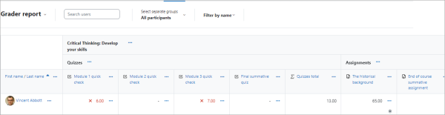](https://docs.moodle.org/403/en/File:GraderReport42.png)

From the three dots next to a category name you can select to

* show grades only
* show grade totals
* show grades and totals.

[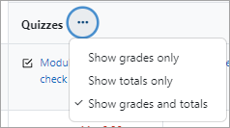](https://docs.moodle.org/403/en/File:categorydots.png)

Collapse columns by clicking the the three dots next to a grade item. Collapsed columns show with a + sign. Click the + to expand them again one at a time. From the Collapsed columns link on the right, quickly see and search how many columns are collapsed.

[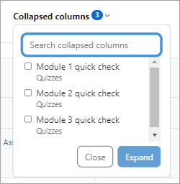](https://docs.moodle.org/403/en/File:collapsedcolumnssearch.png)

The three dots next to a grade item also allows you to:

* switch to Single view.
* change the order (ascending/descending).

[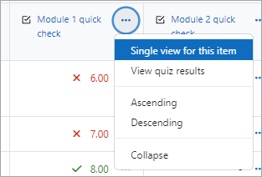](https://docs.moodle.org/403/en/File:gradeitemthreedots.png)

**Scrolling through the gradebook**

The gradebook allows for smooth and stable scrolling horizontally and vertically through grades. It uses the whole window, making it accessible on all platforms.( Note: horizontal scrolling is at the bottom of the browser window, and there is no horizontal scrollbar at the top.)

[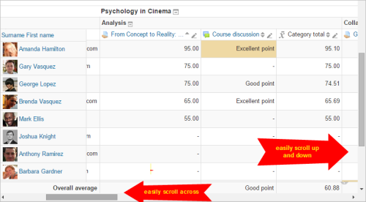](https://docs.moodle.org/403/en/File:scrolling28a.png)

Scrolling in all directions

**Searching and filtering the Grader report**

* If you change the course settings Group mode to Visible groups or Separate groups a drop-down menu will appear in the gradebook to allow you to filter your students by groups.
* You can search easily by starting to type the first few letters of the name of the person (or email or ID number or other user identity item) or group you wish to find.

[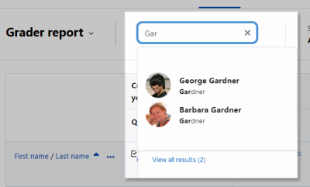](https://docs.moodle.org/403/en/File:Graderreportsearch.png)

**Records per page**

At the bottom of the Grader report, you can select to show 20, 100 or All students on the page.

If you change the setting, it is remembered and applied to the Grader report in all your other courses. If there are more than 5000 students, then All will show 5000, with pagination to show the rest.

**Viewing and editing grades**

Note: Editing anything in the gradebook refers to editing the grades **only** and none of the available operations bear any relationship to editing the main course page i.e. the appearance of your course page cannot be influenced by anything you do in the gradebook. The "Turn editing on" button functions separately from the main course one, so editing can be on in the gradebook, but simultaneously off when you switch back to course view. This is because editing grades and editing the course page are separate capabilities. Roles such as 'non-editing teacher' may only have one or the other.

**Viewing Assignment feedback**

* If you have a given feedback to a learner in an assignment, an asterisk icon will display. Click the three dots in that column to view the feedback in a modal window.

[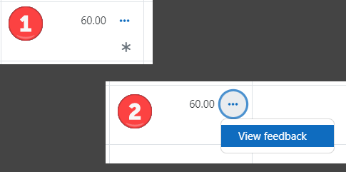](https://docs.moodle.org/403/en/File:feedback12.png)

**Altering the grades**

You can click "Turn editing on" at the top right to enter grades directly in the grader report. When you are done, click 'Save changes'. From the cell actions menu (...) you can also follow the link 'Edit grade' to set the grade, its written feedback and a number of other attributes.

Note: If you enter grades directly in the grader report, they are then shown with an overridden icon to indicate grades which have been manually changed.

**Altering the grades using Single View**

The single view interface allows you to enter grades in bulk for a specific grade item or a specific user. To change a specific grade or all grades, click on the Override checkbox by the specific grade row or use the Override All action to check every row. If you wish to override all grades with a set grade, select Bulk insert grades from the Actions menu and enter the grade that you wish to insert. You can select whether to fill the grade for just empty grades or for all grades from the dropdown list. Click on Save and you will now see in the Grader Report that all grades the specific item/user have been overridden with the grade/grades that you entered.

**Hiding columns or individual grades**

With edit mode enabled, clicking the three dots next to a grade item will give you the option to hide or lock that item (along with options to edit it and view the grade analysis).

**Recalculating**

If you change any part of an assessment e.g. alter the maximum grade for one of the questions in a quiz, you may find that the columns do not yet reflect the change you have made. Click **Turn editing on** twice to force the gradebook to re-check.

**Course grade settings**

Course grade settings determine how the gradebook appears for all participants in the course.

To go to course grade settings from the course page, click the Grades tab then select 'Course grade settings' in the dropdown menu.

The default course grade settings are set by an administrator in *Site administration > Grades*.

**Grader report preferences**

Teachers can set their preferences in Preferences: Grader report. These settings apply to all courses for that teacher. The teacher may change them at any time.

For example, it's possible to set the grader report to only show active participants or all participants (including suspended users) from the *Show only active enrolments* setting. Users may be suspended from the course by changing their status via the [Participants](https://docs.moodle.org/403/en/Participants) page. The user's role must not be removed when suspending the user or they will not show up in the grader report even if the "Show only active enrolments" option is set to "No."

The default grader report preferences are set by an administrator in *Site administration > Grades > Grader report*.

Note: The setting 'Number of students per page' is removed in Moodle 4.2 and replaced with a records per page selector at the bottom of the Grader report.

**Site administration settings**

Default values for all grade settings can be set by an administrator. The easiest way to do so is to log in as admin then browse a course gradebook and follow the 'Change defaults' links.

The following additional grade settings can be found in *Site administration > Grades > General settings*. The settings will affect all gradebooks used by all teachers.

**Graded Roles**

Graded roles are the type of user that will appear in the gradebook. Most of the time "student" is the only one needed.

**User profile report**

The default user profile report setting has just one option, 'User report', unless a custom user report has been added to the site.

Teachers can view the user reports for all or selected students in the course via the Grades tab then selecting 'User report' in the dropdown menu.

**Include scales in aggregation**

Scales can be included as numbers in all aggregated grades across all gradebooks in all courses. Changing this setting will force all aggregated grades to be recalculated.

If this is checked (and it is by default) then all custom scales will have a corresponding value that is assigned based on the number of options in the scale (i.e. three values will have values of 1,2,3) and this will be included in the grade aggregation.

**Enable publishing**

Grade publishing is a way of importing and exporting grades via a URL without being logged in to Moodle. Grade publishing is intended for administrators or managers only. Security implications should be thoroughly considered before allowing other users to publish grades. Grade publishing is controlled by the following capabilities:

* [Publish ODS grade export](https://docs.moodle.org/403/en/Capabilities/gradeexport/ods:publish)
* [Publish TXT grade export](https://docs.moodle.org/403/en/Capabilities/gradeexport/txt:publish)
* [Publish XLS grade export](https://docs.moodle.org/403/en/Capabilities/gradeexport/xls:publish)
* [Publish XML grade export](https://docs.moodle.org/403/en/Capabilities/gradeexport/xml:publish)
* [Publish import grades from XML](https://docs.moodle.org/403/en/Capabilities/gradeimport/xml:publish)

Grade publishing may be enabled by checking the gradepublishing box. If enabled, administrators and users with the required capabilities (by default the role of manager only) are provided with [grade export](https://docs.moodle.org/403/en/grade_export) publishing settings in each course gradebook.

**Recover grades default**

When [manually enrolling](https://docs.moodle.org/403/en/Enrolled_users) a student in a course, there is an option 'Recover user's old grades if possible', however this checkbox is easy to miss. Enabling 'Recover grades default' (recovergradesdefault) in Site administration > Grades > General settings results in 'Recover user's old grades if possible' being ticked for every course.

When this setting is enabled, the grades will be automatically recovered on re-enrollment with any enrollment method, not just manual - such as "Cohort sync", "Self-enrolment", etc. including the 3rd party enrollment plugins.

Please note that grades are recovered from the grade history. If the grade history is disabled, the grades recovery will not work even if enabled.

[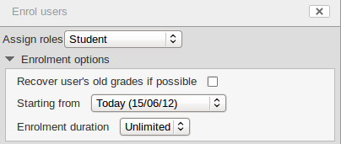](https://docs.moodle.org/403/en/File:enrol_users_enrolment_options.png)

**Unlimited grades**

Teachers can enter grades over 100% directly in the gradebook if the *unlimitedgrades* setting is enabled.

**Grade point maximum/Grade point default**

The administrator can set here the maximum point value in activities, and also the default point value which will appear when a teacher uses points for activities in their course. (Both these are set to 100 initially)

[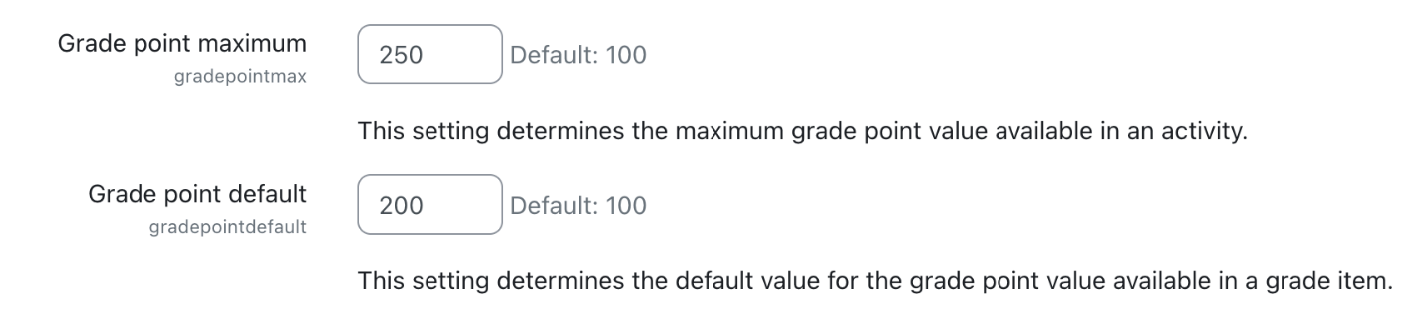](https://docs.moodle.org/403/en/File:gradepointmaxdefault.png)